**DATABASE MANAGEMENT SYSTEM**

**LAB-8**

**FUNCTIONS AND STORED PROCEDURES**

**NAME: VISHWAS M**

**SRN : PES2UG20CS390**

**SEC : F**

**DATE : 20/10/2022**

1)FUNCTIONS:

Query and output for creating the function:

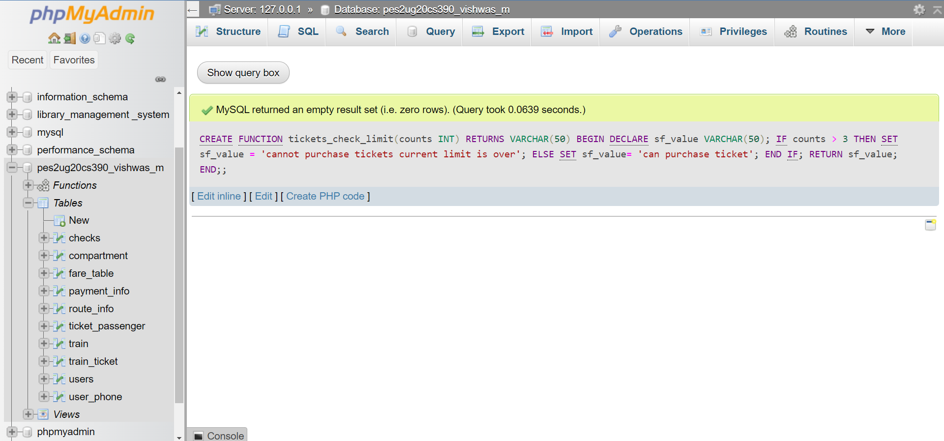

Output after calling the function:

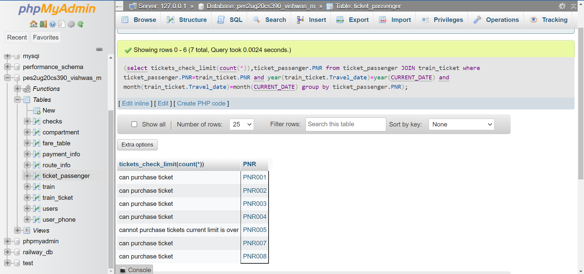

2)PROCEDURES:

Before updating:

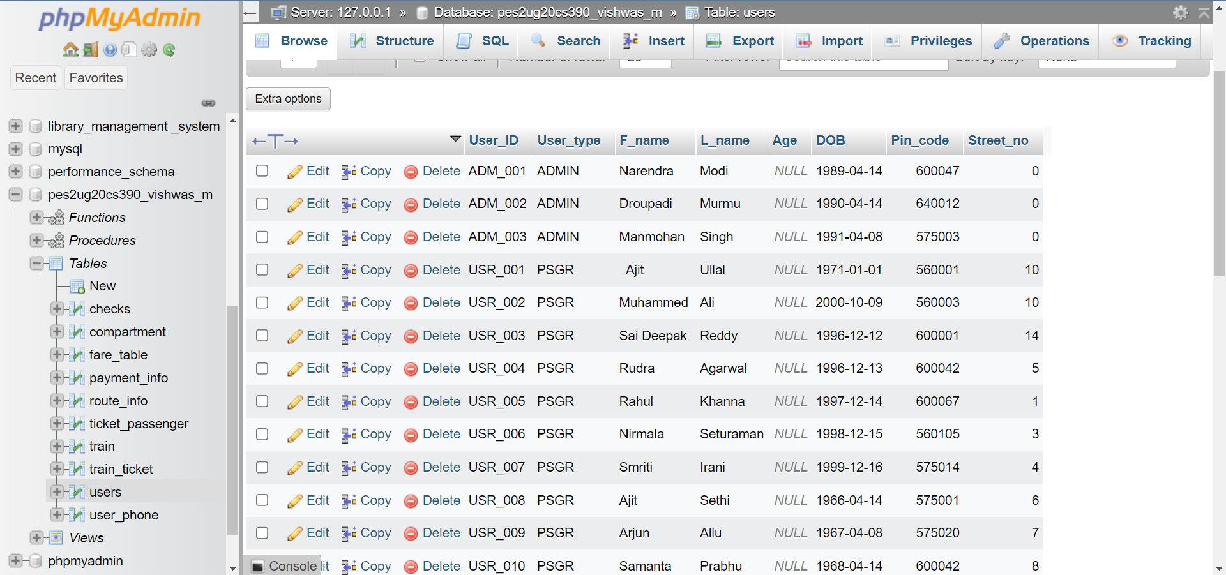

Query for 1st procedure:

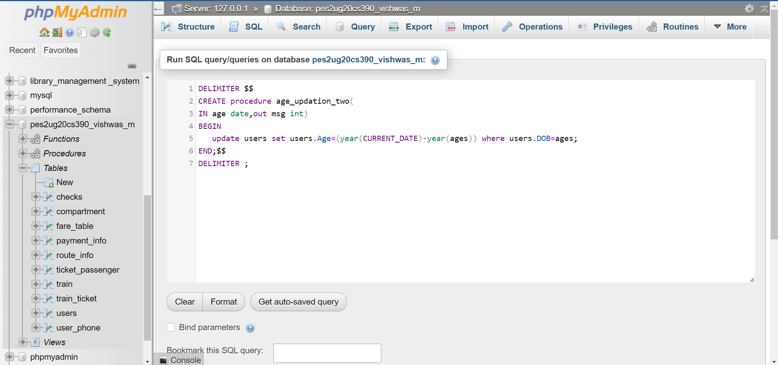

Output :

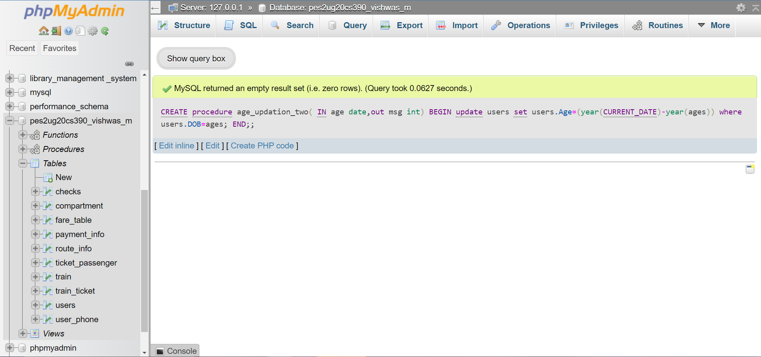

Query for 2nd procedure:

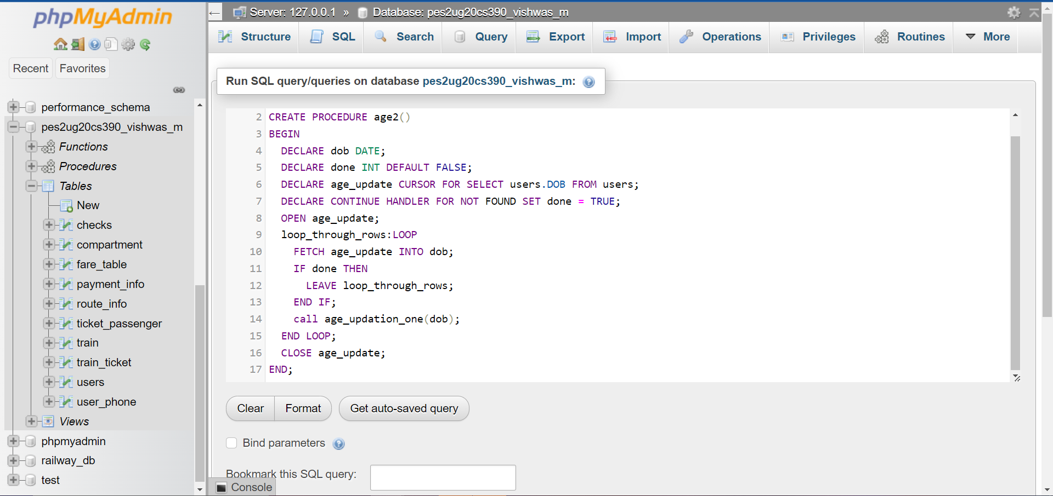

Output for 2nd procedure:

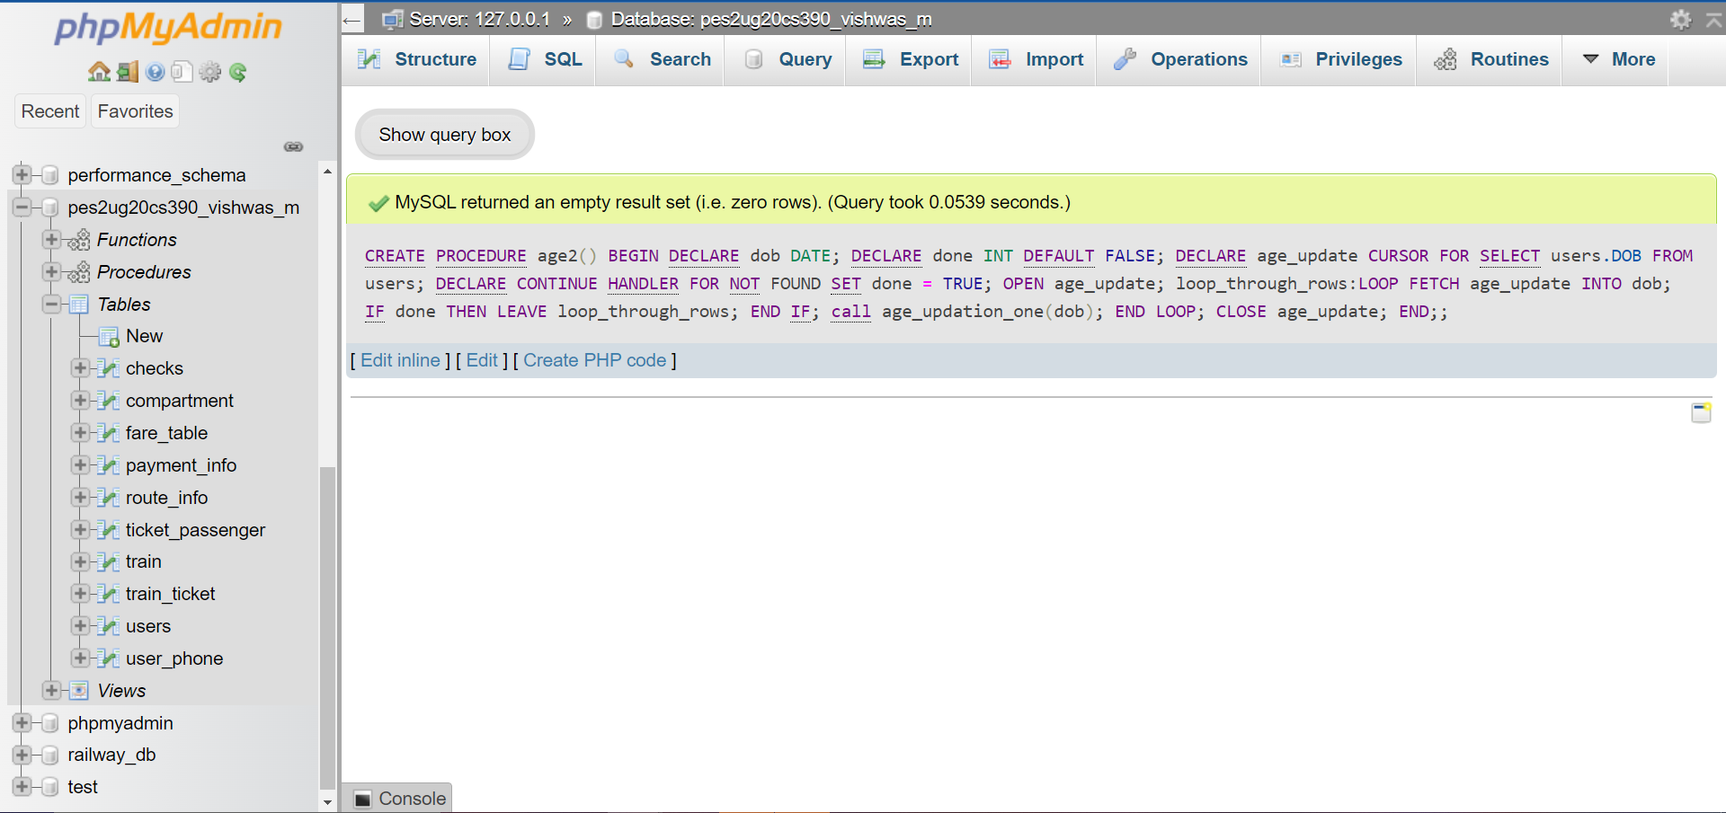

Calling the 2nd procedure:

Query:

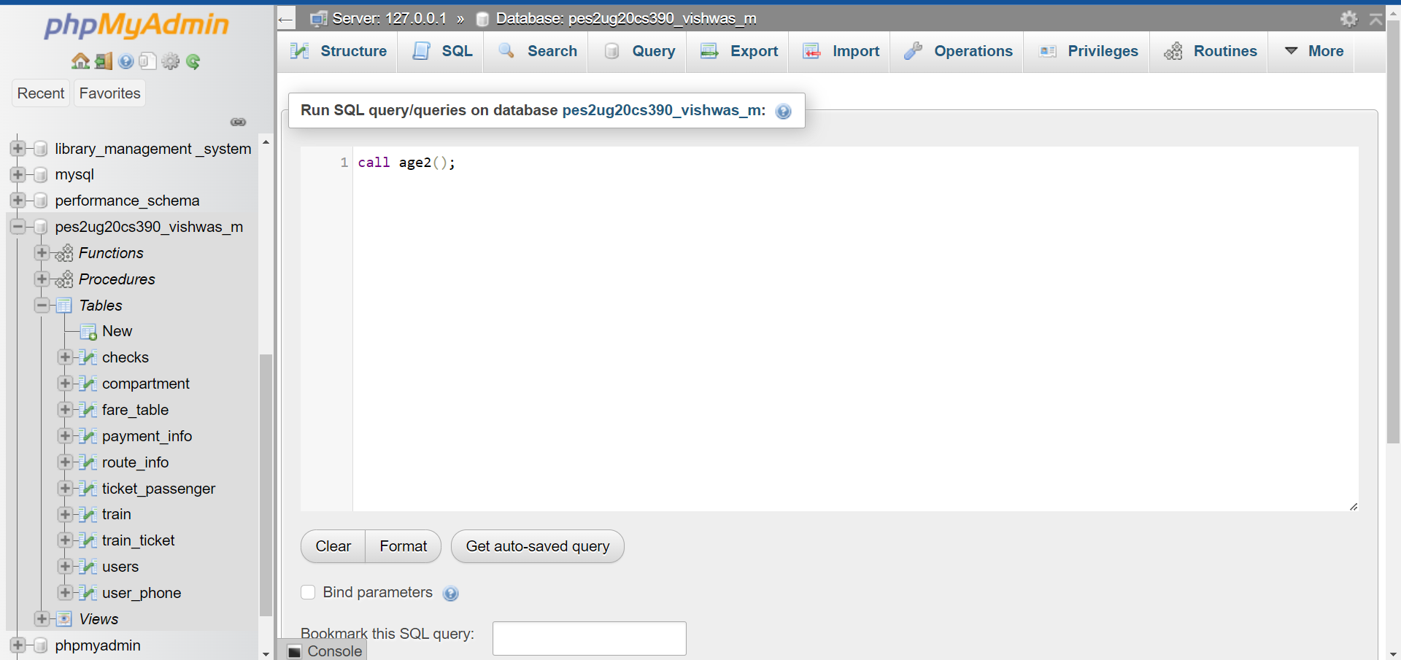

Output:

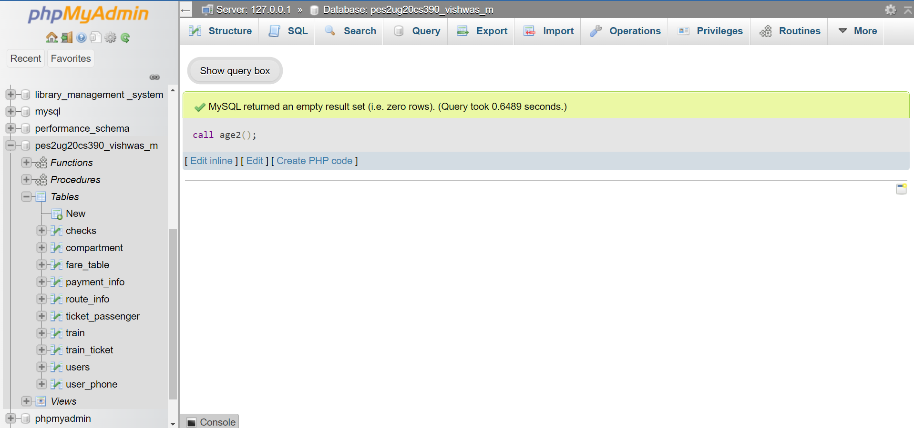

The updated table:

